ADPC

Windows Activity Fund

Year End Procedures

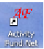

End of the Year Procedures:

- ⁭ The first thing you need to do is close out the month of June. June close out will also delete any open purchase orders. You will want to print an Outstanding Invoice report. All invoices must be closed (created into checks) or removed. (See Chapter IV - Invoices of the manual on how to remove invoices.) Please be sure that all of your reports for June are printed and are correct. After you close out for June using June 30 date, be sure to log out, and then back in for the close out to take effect.
- ⁭ Go to Reports and click on Accounts and then print a Summary of Accounts (YTD) Year to Date report. Include subaccounts if you use them. Also print a Statement of Change report for your auditor.
- ⁭ It might be a good idea to click on Adjustments and Print an Adjustment Register and Print a Transfer register and select the dates for the year.
- ⁭ Click on Expenditures and Print a Check Register and Print an Outstanding Checks report.
- ⁭ Under Financials, click on Detail of Account (YTD) Year to Date, All accounts. This is a large report and will take a lot of paper. *NOTE*
- ⁭ Click on Revenues and Print a Receipt Register for the year.
- ⁭ Once you have printed all of your reports and they are correct, you are ready to run your Bold Code reports. (See Chapter IX Reports-Bold Code of the manual.)
- ⁭ **NOTE** You need to correct any errors you have before creating your files. (See section Bold Code Changes of the manual). Once you have re-run your bold codes and they are correct and they have no errors, the Activity expend and revenue files are ready to be created. (See Chapter IX Reports-Bold Code). The Activity files will need to be merged with Accounts Payable and Treasury files and submitted to the State Dept.
- ⁭ Click on File and down to Close-out Processing. Click on Year-end Close out. The program will remind you to print any reports you may have forgotten and then create a Year End backup.
- ⁭ It will ask you for your next PO#, Check#, Receipt# and Deposit#. It usually defaults to the next available number. You can change the number here if you want too.
- ⁭ Read the close out prompts. Once close out has been successful, please log out and back in so the New Year close out will take effect.
- ⁭ It is a good idea to print a Summary of Accounts to make sure account balances did roll forward and closeout was a success before entering New Year work.

Please call us if you have any problems or questions we can help you with.

*NOTE* REPORTS CAN BE SAVED TO A FILE INSTEAD OF PRINTING.
ALWAYS SAVE AS TYPE: ADOBE PDF

**NOTE** CREATE BOLD CODE FILES AFTER YOU CLOSE OUT FOR JUNE.

Bold Code Changes:

If you run a Bold Code report and have errors, you can change the codes by individual items or by a batch.

Run or print the Bold Code listing by expenditures or by revenue if your Bold Code contains errors. The listing shows how many items you used for a particular code, the value or code that contains the error, the total expense for items used for that code and explains the warning and error messages. (See Chapter IX Reports - Bold Code section)

To correct those errors, click on System and down to OCAS and over to Bold Coding Expense or Bold Coding Revenue. A message will appear like the one below:
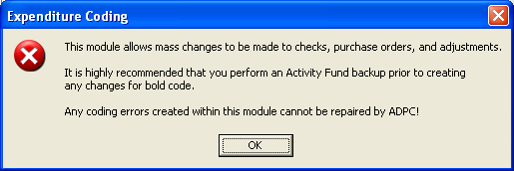
When you click OK, be sure to make a backup and then you can continue with the changes.

Once you click OK to the backup message, a screen will appear like the one below:
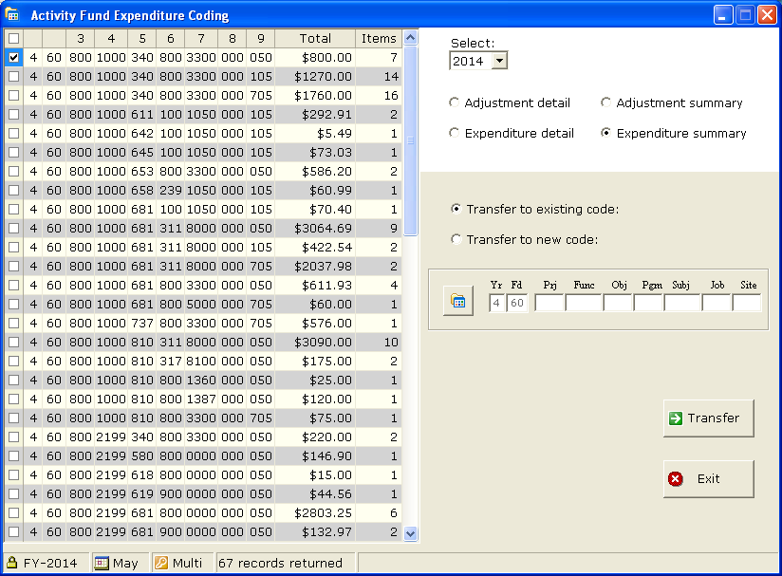

The Expenditure Summary and Transfer to existing code options are selected for you.
The Expenditure Summary option allows you to see how many items use a particular code, same as the Adjustment Summary. The code selected above has 7 items that use that code. You can change all 7 codes at once if the Expenditure summary is selected or you can select Expenditure detail to change the codes individually. The Expenditure detail shows a list of individual check numbers and detail of those codes, same as the Adjustment detail. Be sure to check the Adjustment options also for code errors.

Select (checkmark) the items you want to change to the correct code with Transfer to existing code selected. If the code has not been used before click Transfer to a new code and the program will create a new code for you.

Enter all of the correct code after the year and fund in the appropriate white boxes or click the Code icon button (in the middle of the screen) that shows a window of available codes. When selecting the Code icon button, just highlight the correct code and click the green arrow Select button to change all of the code in the white boxes.

Next, click the Transfer green arrow button to transfer to the existing or new code you selected to the items you need changed.

*NOTE: When selecting the Code icon button, under Options you can Create Expenditure code or Create Revenue code and description if the existing code does not appear. After entering the new code and description be sure to click the Save button and then highlight the code you created before clicking the Select button. The new code can also be created under OCAS Expenditures or OCAS Revenue.

*NOTE: Select fiscal year to correct bold code.

